**The College of New Jersey**

**E/CE Department**

**School of Engineering**

**Senior Project Proposal**

Title of Project: ___________Handheld Oscilloscope __________________________

Semester: ___Spring__________ Date: _____3/14/2020________

Student Name: ____Brian Worts____ Project Advisor: Larry Pearlstein___

Email: __wortsb1@tcnj.edu________ Academic Adviser: _____Larry Pearlstein____

Team Members: ___Chris Jenson_________________ _____Dr. Deese_________

(over 4 requires approval of Department Chair) Department Chair

Formulation and Statement of Design Problem:

(Include **your** specific role on the project) (not handwritten)

We will be designing an oscilloscope to measure changes in voltage over a period of time and display that waveform.

My role will be to handle all tasks relating to the FPGA. This will include creating timing generation for the ADC, buffer and memory management, trigger logic for the waveform, and interfacing between the FPGA and other components.

Planned Approach to Design Activity:

(Include **your** proposed outcomes and deliverables) (not handwritten)

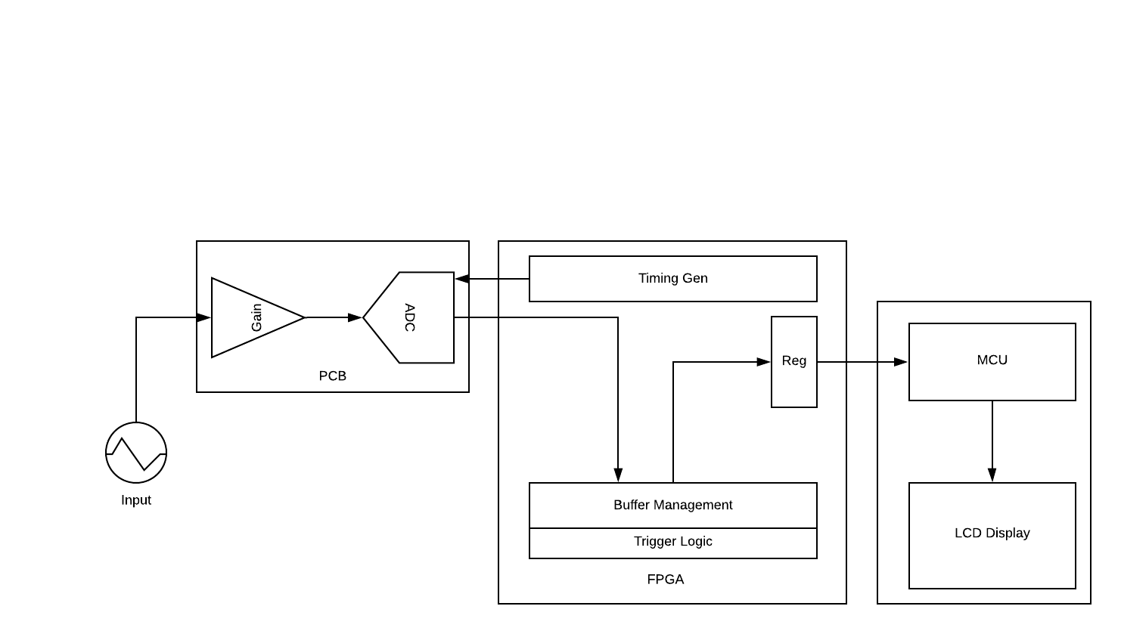

In order to accomplish this goal, the team will utilize an FPGA that will perform analog to digital conversions of a signal at a desired frequency. An external ADC may also be utilized if on-board ADCs do not meet the required sampling frequency. The user will also be able to control the gain of the input signal. The adjustable gain and the ADC may be placed together on a PCB. The ADC will interface with the FPGA board to perform the needed operations and store the data for display. This FPGA will then send data to a PSOC controller that interfaces with a display to show the signal waveform. This display will be able to show the signal in the frequency or time domain, have selectable positive or negative slope triggering, able to scroll horizontally/vertically, and have an overlaid graticule.

The goal of this project is to have a functioning and portable oscilloscope built using FPGA boards and PSOC controllers as well as ADC and selectable gain components.